

Queensland University of Technology

Science and Engineering Faculty

Information Systems

**Web application report**

Assessment 3

Unit: IAB207 – Rapid Web Application Development

Group: Manual_allocation 4

Members: Krystof Novak (n10731067), Kyle Holmes-Brown (n10211756), Jacob Knights (n10604596)

June 2020

## Info

Heroku URL (on Heroku images are not displaying):

<https://vehicle-polis.herokuapp.com>

GitHub repository URL:

<https://github.com/novakkry/vehicle-polis>

## Progress table

|  |  |  |  |  |
| --- | --- | --- | --- | --- |
| Date | 11/06 | 12/06 | 13/06 | 14/06 |
| Task | Cleaning the HTML code from Assessment 2, setting up a folder project structure, editing HTML templates so it's ready for development. | Created database, created HTML base template, created login and registration form | Created User and Post model, registration and login process done, created account page | Created add_item template, created the whole adding a new item process |
| Author | Krystof Novak | Krystof Novak | Krystof Novak | Krystof Novak |

|  |  |  |  |  |
| --- | --- | --- | --- | --- |
| Date | 15/06 | 16/06 | 17/06 | 18/06 |
| Task | Created item details template, edit and delete of listing function, added list of listed items in account page, created the whole order process including forms, database model and templates | Created the whole review system including template, model and form, fixing some bugs | Created category search, creation and setting up of Heroku, first Heroku deployment | Editing styles, fixing minor bugs, small overall improvements, report creation, final testing, final version Heroku deployment |
| Author | Krystof Novak | Krystof Novak | Krystof Novak | Krystof Novak |

## Screenshots of pages mentioned in test script

### Landing page

On the landing page, user can log in, log out, register, search by category, list a new vehicle, look at his account. At the bottom of the page there is a carousel with the latest posted items.

After clicking on “Search vehicles” button, app will show the vehicles within specified constrains. Only used constrains are respected – that means if user keeps the search form empty, it shows him all the results. If he only specifies maximum price, it will show him all the results meeting the price criteria, the rest of the constrains are neglected. If he ticks certain car makes, specifies max ODO and year, the search by category function will show results meeting the car makes, ODO and year criteria, the rest of criteria is neglected. And so on.

## 

### Account page

On account page, user sees some information about his account, list of his listed items and history of orders. From here he can delete/edit listings.

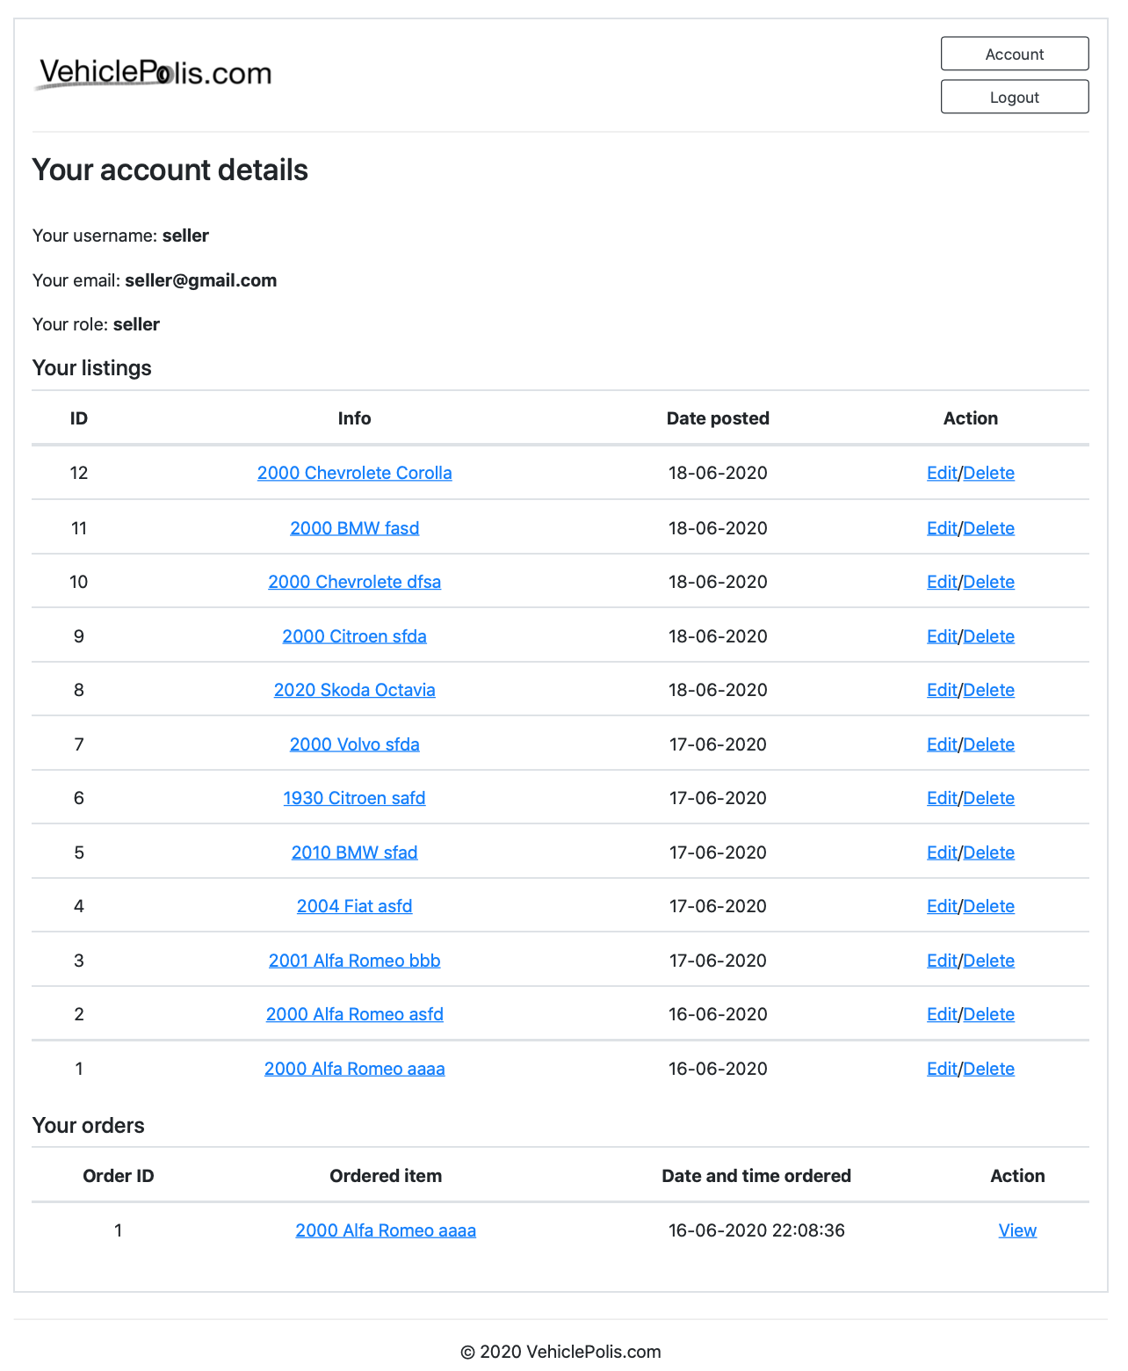

## Add item page

If user is logged in and has a role as seller, he can list item. All the form fields are protected for invalid inputs. If user doesn’t upload an image, default image is used.

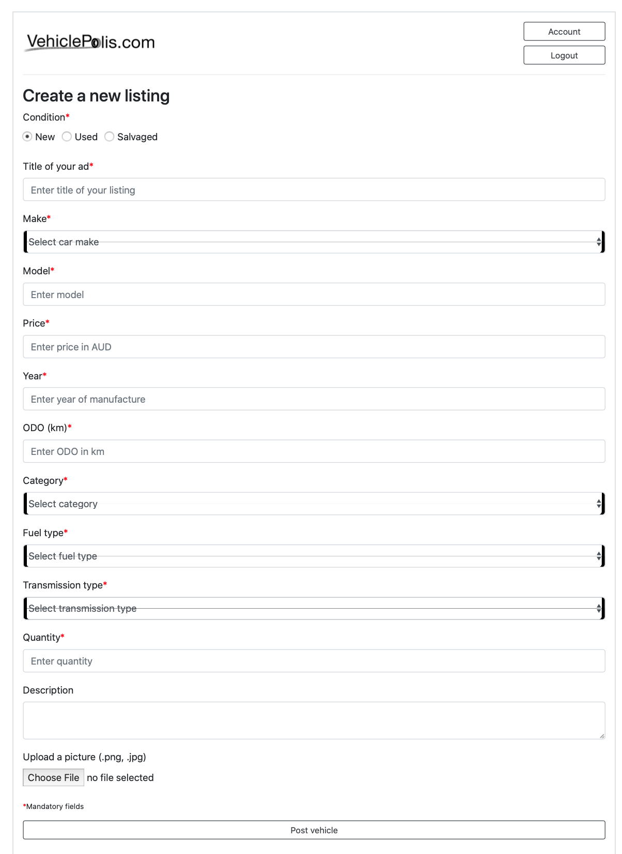

## Item details page

On the item details page user sees the details of certain listing. If he purchased that item and is logged in, he can post a review. If he doesn’t meet the criteria, he doesn’t see the form, but he can see reviews that other posted. On the picture is a default image.

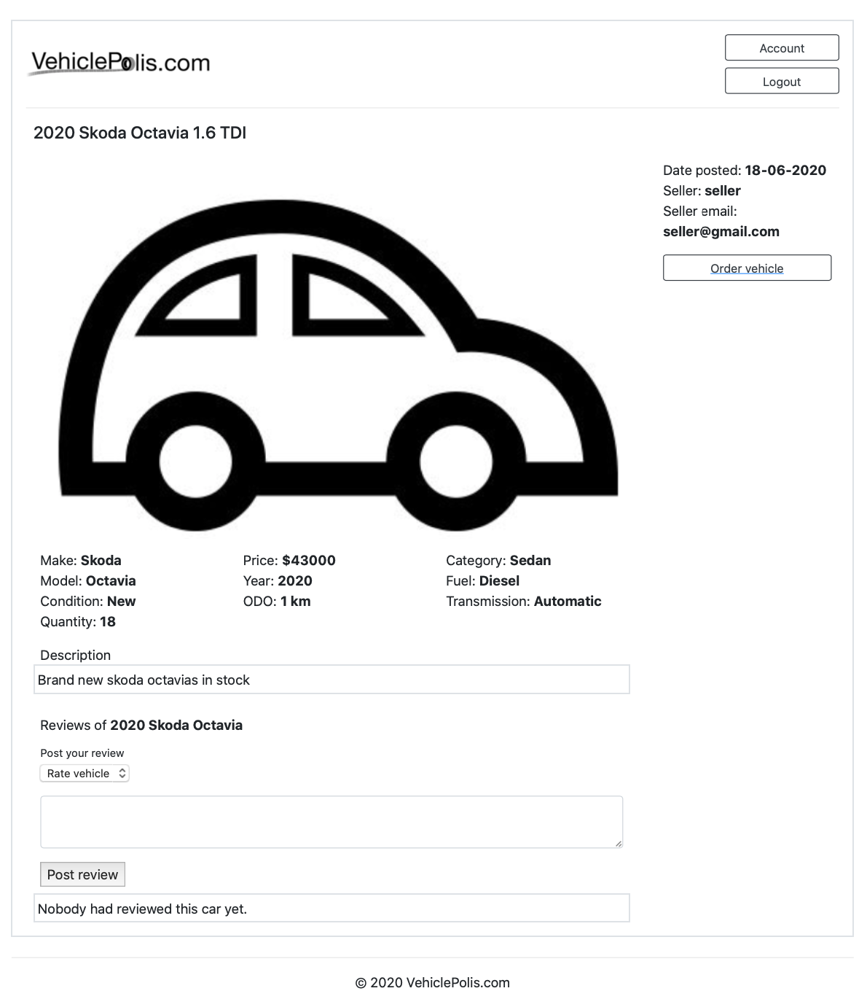

### Login page

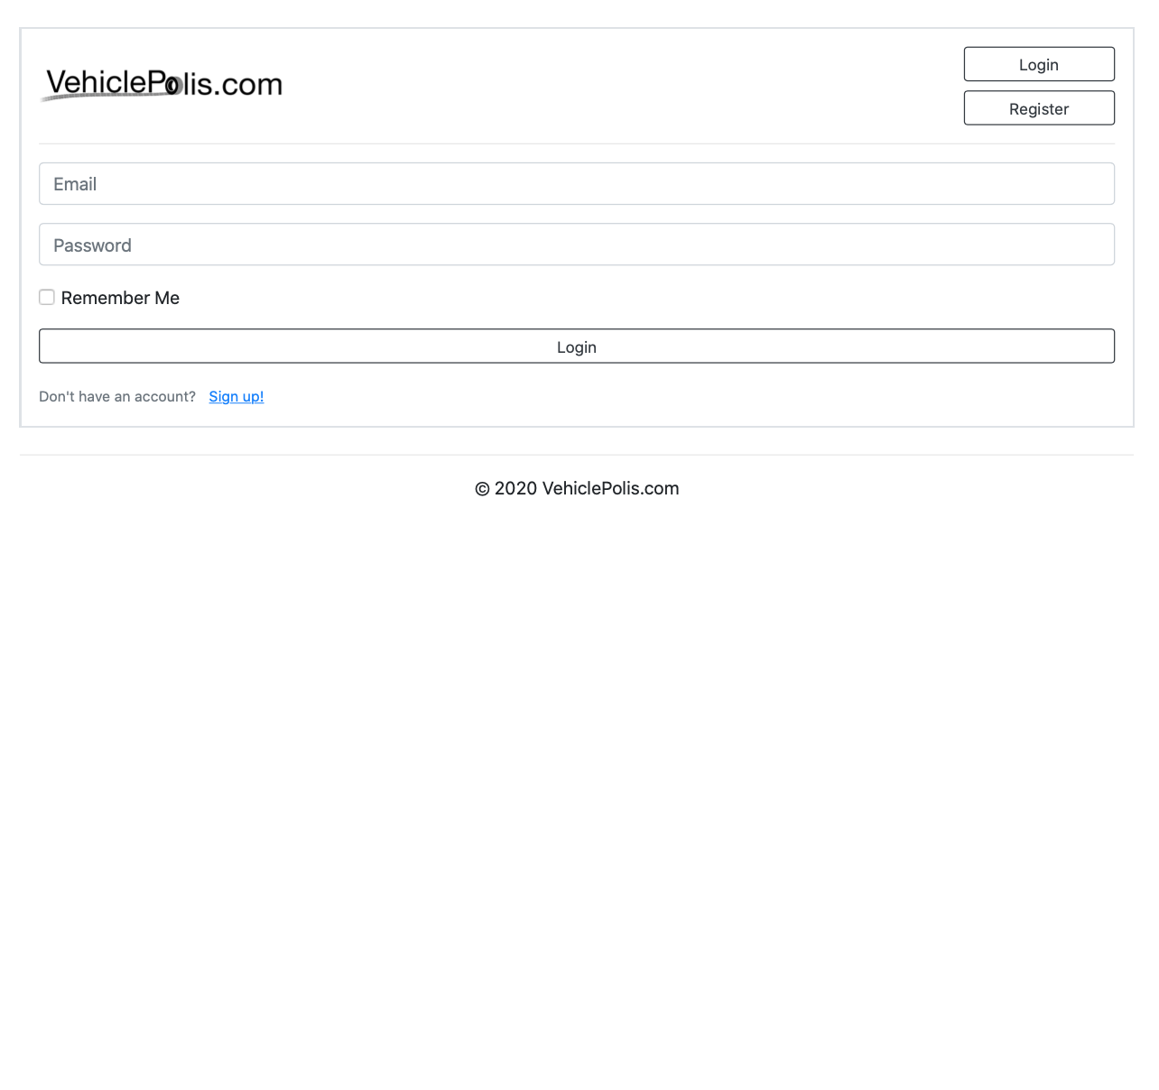

### Order item page

If user is logged in and it’s not his own listing, he can order an item. If the quantity is more than quantity available, it will display a warning to change the amount of quantity. After submitting order, the available quantity is decreased by the amount the user bought. All the form fields are protected against invalid inputs.

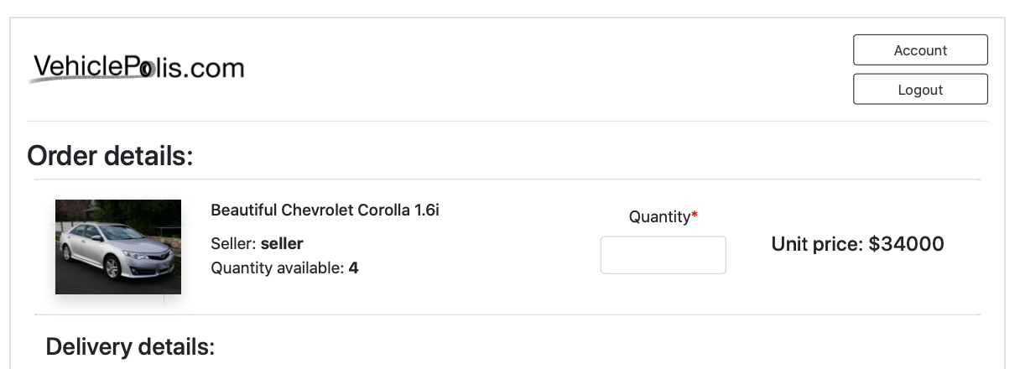

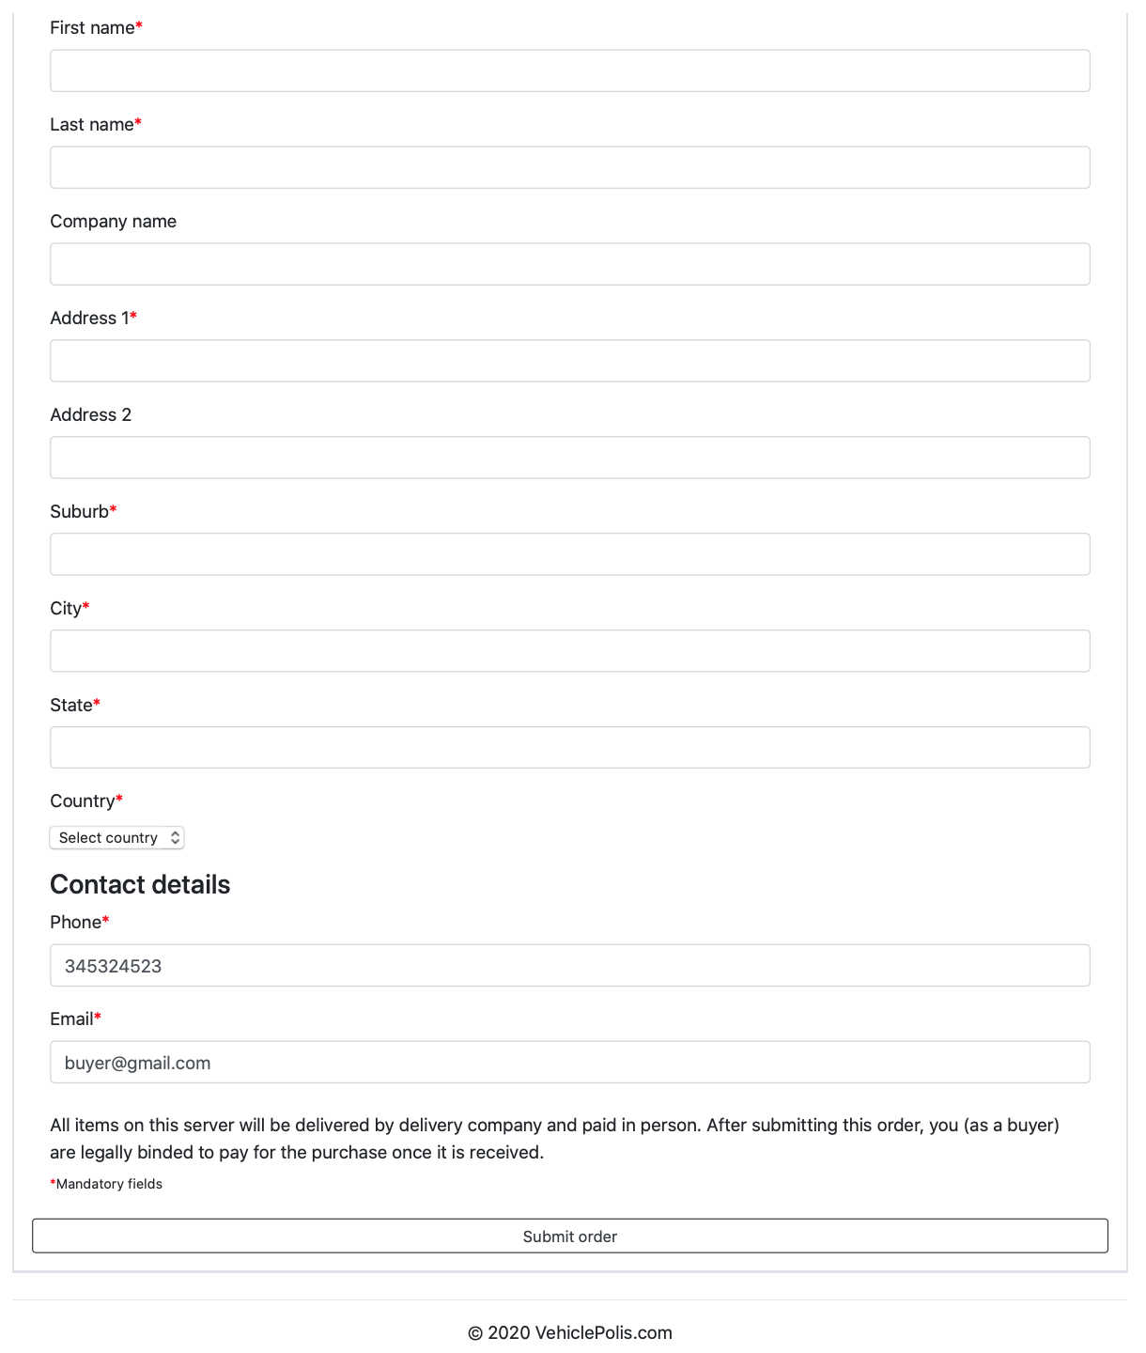

### Order details page

After submitting an order, user sees a summary of his order. He can access this summary also from his account page where is a history list of ordered items.

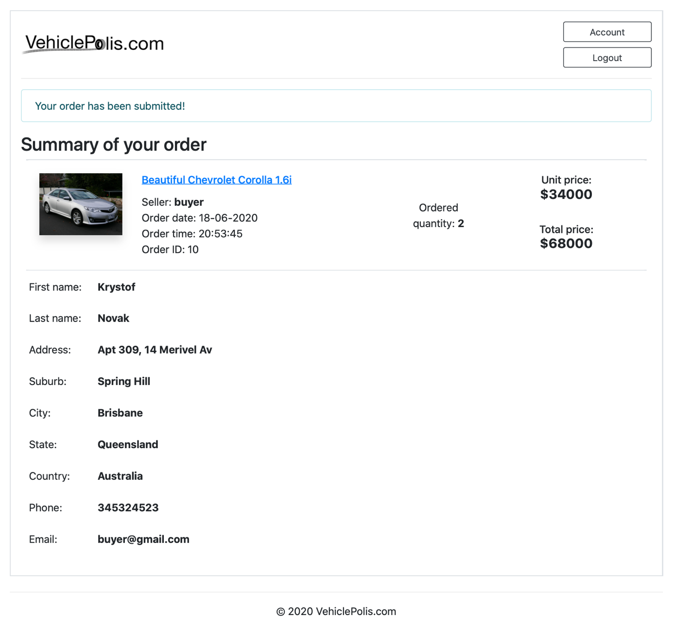

### Register page

A user can register as buyer or seller. If he is registered as a buyer, he can’t post items.

